**DBMS Model Questions 2022 Scheme**

**Module 1**

1. Explain the characteristics of database approach.

2. Explain the advantages of using DBMS Approach.

3. Explain three schema Architecture.

4. Define data independence. Explain types of data independence.

5. Explain database languages and Interfaces.

6. Discuss the various component modules of a DBMS and their interaction with a neat diagram.

7. Draw ER diagram of Company Database.

8. Draw ER diagram of Bank Database

10.Define an entity and an attribute. Explain the different types of attributes that occur in the ER model, with an example.

11. Explain the Structural Constraints,

12.What is the cardinality ratio? Explain the possible cardinality ratios for binary relationship types with an example

**Module 2**

1. Explain primary key , referential integrity and foreign key concepts with the specific example
2. Explain union, Intersection and Minus Operations of Relational algebra with examples
3. Describe Selection and Projector Operator in Relational Algebra and mention the difference between them with examples.
4. Develop the following queries in Using Relational Algebra.
5. Find the names of all the employees whose salary is greater than 30000.
6. Retrieve the name and emp id of all employees.
7. Find the fname and lname of employees in department 4 that earn > 50000
8. Explain different types of Joins in SQL
9. Explain relational model constraints.
10. Describe the different Join Operators with examples.
11. Explain different steps of ER to Relational Mapping algorithm.
12. Convert the following ER Diagram to Relational Model

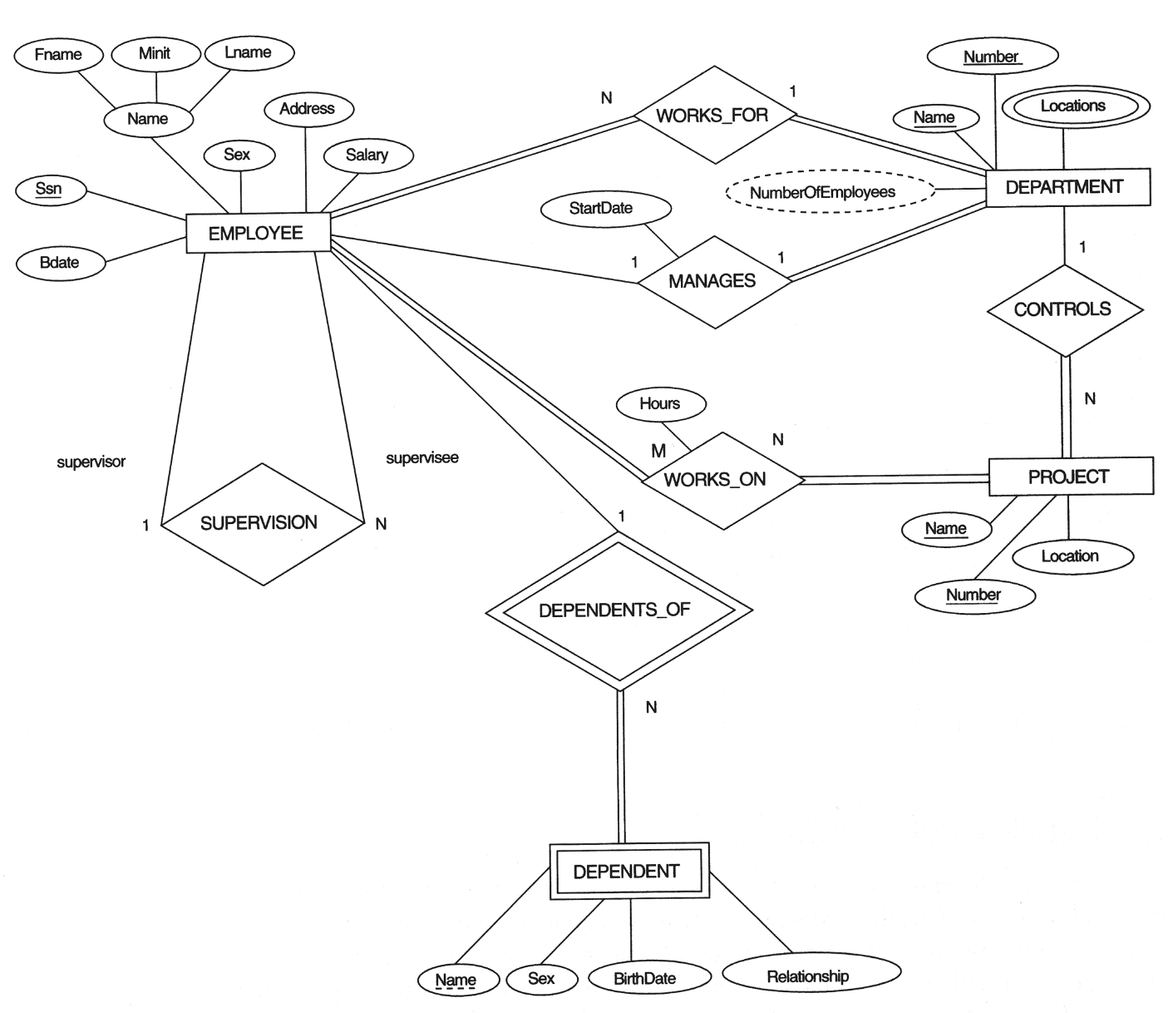

**Module 3**

1. Explain the data types that are allowed for SQL attributes.
2. Outline the different constraints in SQL while creating table.
3. Explain the schema change statements of SQL
4. Write the SQL queries for the following:
5. Write the syntax to Create, Alter and Drop table.
6. Write SQL Query to Create Employee table with the following attributes: eid, ename and salary.
7. Alter table employee by adding one more attribute called address.
8. Give syntax to drop table employee and drop column salary.

5. Write the SQL queries for the following:

1. Retrieve the birth date and address of employee whose employee id is 10.
2. Retrieve the name and address of all employees who work for ‘Research’ department.
3. Retrieve all employees in department 5 whose salary is between 30000 and 40000
4. Retrieve distinct salaries of employees.

6. Explain the ALTER TABLE command. Explain how the new constraint can be added and also an existing constraint can be removed using suitable examples.

7. Explain INSERT, DELETE, UPDATE statements in SQL taking suitable examples.

8. Explain the aggregate functions in SQL? Explain with examples.

9. Explain the command used for ordering the query results? Explain with the syntax and an example

10.Write SQL queries for following:

Student( Enrno, name, courseId, emailId, cellno)

Course(courseId, course_nm, duration)

1. Add a column city in student table.
2. Find out list of students who have enrolled in “computer” course.
3. List name of all courses with their duration.
4. List name of all students start with „a‟.
5. List email Id and cell no of all mechanical engineering students

11. Explain Group by and having clause in SQL with an example.

12. Explain Views in SQL. Give the syntax to create and drop views.

13. Consider the below table:

Orders(ord_no , purch_amt, ord_date , customer_id, salesman_id)

1. write a SQL query to calculate total purchase amount of all orders.
2. write a SQL query to calculate the average purchase amount of all orders.
3. write a SQL query that counts the number of unique salespeople.
4. write a SQL query to find the maximum and minimum purchase amount.

14. Develop the SQL queries for the following:

1. Retrieve the birth date and address of employee whose employee id is 10.
2. Retrieve the name and address of all employees who work for ‘Research’ department.
3. Retrieve all employees in department 5 whose salary is between 30000 and 40000
4. Retrieve distinct salaries of employees

**Module 4**

1. Construct Functional Dependency. Give Inference rules for Functional Dependencies.
2. Explain 1NF with example.
3. Explain 2NF with example.
4. Explain 3NF and BCNF with example.
5. Consider the below Relation

R{City, Street, HouseNumber, HouseColor, CityPopulation}

Assume key as {City, Street, HouseNumber}

The Dependencies are:

{City, Street, HouseNumber} 🡪 {HouseColor}

{City} 🡪 {CityPopulation}

Check whether the given R is in 2NF? If not convert into 2NF

1. Consider the relation

Emp-Proj ={SSN, Pnumber,Hours, Ename,Pname,Plocation}

Assume {SSN,Pnumber } as Primary key

The dependencies are:

{SSN,Pnumber}->Hours

SSN->Ename

Pnumber->{Pname,Plocation}

Normalize the above relation to 3NF

1. Consider the following relation

R {Title, PubId, AuId, Price, AuAddress}

Assume primary key as {Title, PubId, AuId}

The Dependencies are

{Title, PubId, AuID} 🡪 {Price}

{AuID} 🡪 {AuAddress}

Check whether the given R is in 2NF? If not convert into 2NF

1. Consider the following relation R {Studio, StudioCity, CityTemp}

Assum e Primary Key as {Studio}

The Dependencies are:

{Studio} 🡪 {StudioCity}

{StudioCity} 🡪 {CityTemp}

Check whether the given R is in 3NF? If not convert into 3NF

1. Give the minimal cover Algorithm. Find the minimal cover using the minimal cover algorithm for the following functional dependency.

F = {B->A, D->A,AB->D}

1. Give the minimal cover Algorithm. Find the minimal cover using the minimal cover algorithm for the following functional dependency.

F = {B->A, D->A,AB->D}

**Module 5**

1. Explain the desirable properties of Transactions.
2. Explain Different states of Transactions with Diagram.
3. Explain Why concurrency is needed?
4. Develop the steps involved in read and write operations of transactions
5. Explain the operations of transactions.
6. Explain the reasons for failure of transactions
7. Explain Deadlock and Starvation.
8. Explain the characteristics of NoSQL Databases.
9. Explain Types of databases of NoSQL
10. Define the Graph database. List the advantages and Disadvantages of Graph databases
11. Compare NoSql and RDBMS
12. Explain the need of Schemaless database